

Practices for Secure Software Report

Table of Contents
Document Revision History 3
Client 3
Instructions 3
Developer 4
1. Algorithm Cipher 4
2. Certificate Generation 4
3. Deploy Cipher 4
4. Secure Communications 4
5. Secondary Testing 4
6. Functional Testing 4
7. Summary 4
8. Industry Standard Best Practices 4

Document Revision History

Version | Date | Author | Comments
1.0 | 02/20/2026 | Elijah Prosperie

Client



Instructions

Submit this completed practices for secure software report. Replace the bracketed text with the relevant information. You must document your process for writing secure communications and refactoring code that complies with software security testing protocols.

- Respond to the steps outlined below and include your findings.
- Respond using your own words. You may also choose to include images or supporting materials. If you include them, make certain to insert them in all the relevant locations in the document.
- Refer to the Project Two Guidelines and Rubric for more detailed instructions about each section of the template.

Developer
Elijah Prosperie

Algorithm Cipher

For our company, Artemis Financial, I have decided to use the Secure Hash Algorithm 256-bit. Better known as it’s abbreviated term of SHA-256. My logic behind this choice being that the SHA cipher is both extremely supported, secure, and providing a strong counter to data threats. Ensuring users can have confidentiality and data integrity for their work through the use of enhanced hashing. The SHA-256 uses a 32-byte hash value that is fixed. Meaning that it will not change even with input size. Adding a layer of protection by verifying to the user if the data has been altered or not.

The SHA-256 is a massive improvement on previous ciphers used throughout history. Mainly due to its impressively large bit size of 256. Being so large means that there is an almost zero chance of two different inputs producing the exact same hash value. This is important due to making it extremely difficult for a threat actor to brute-force their way into the encryption.
Another factor regarding SHA-256 is how it is a symmetric encryption. This means it can be used for encrypting large quantities of data over time. Making your data safe and protected in bigger projects. Contrasting asymmetric encryption that is used for quick transfers of data such as key exchange. Making SHA the optimal choice if you want a scalable, building database that can grow over time.

Most modern cryptographic systems use a secure random number generation to help create a secure blanket to promote confidentiality, integrity, and authenticity of a user's work. These random numbers create unpredictable encryption keys, digital certificates, and more. All accomplished by generating strong keys that are difficult for a threat actor to attack or guess. The more random these keys may be. The tougher the system will be to break in. These keys differ as well when considering asymmetric and symmetric encryption. Symmetric encryption shares a single key that handles the encrypting and decrypting. These excel in large scale projects due to their speed. While asymmetric encryption uses a pair of keys, a public and private key, to handle the decryption and encryption separate.

Encryption has come a long way to what we have now. With older algorithms being easily broken due to short keys. AES took over as the federal encryption standard in 2001. Replacing the former standard of 3DES. AES-256 stands as one of the strongest and respected encryption standards. It is my choice for this project and one I feel is justified in its use.

Certificate Generation
Insert a screenshot below of the CER file.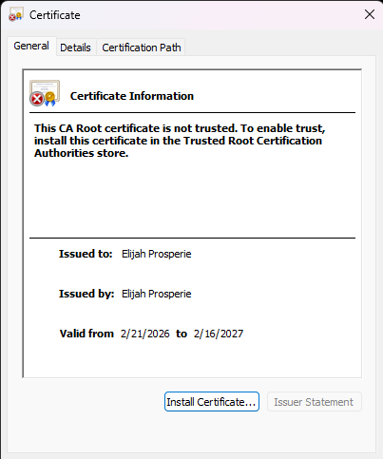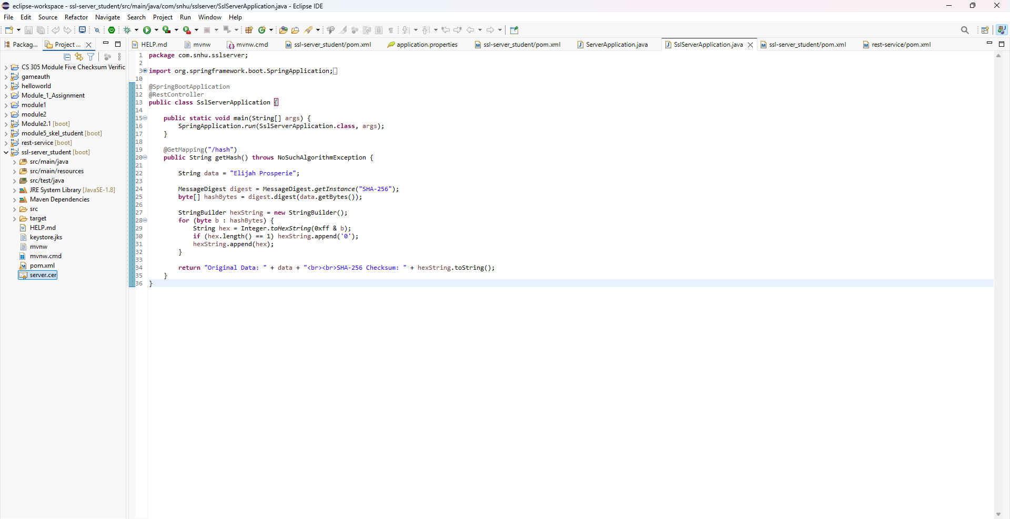

Deploy Cipher
Insert a screenshot below of the checksum verification.

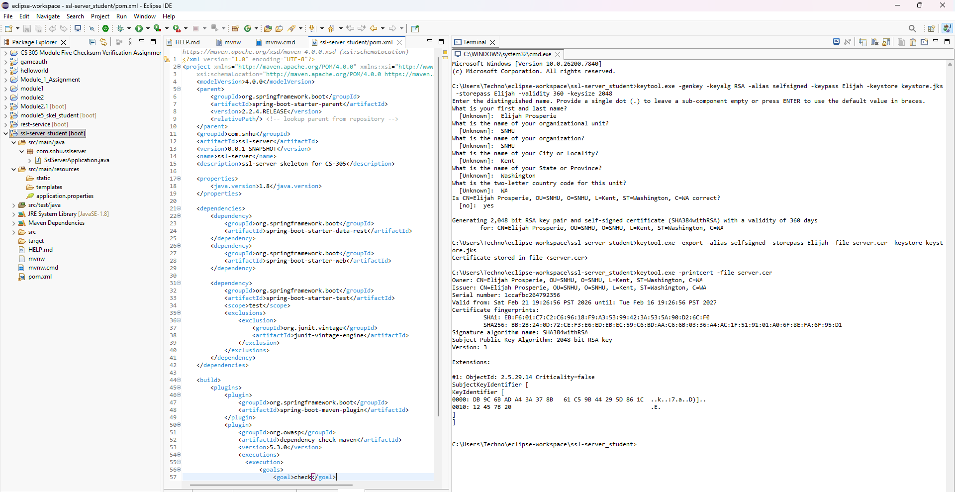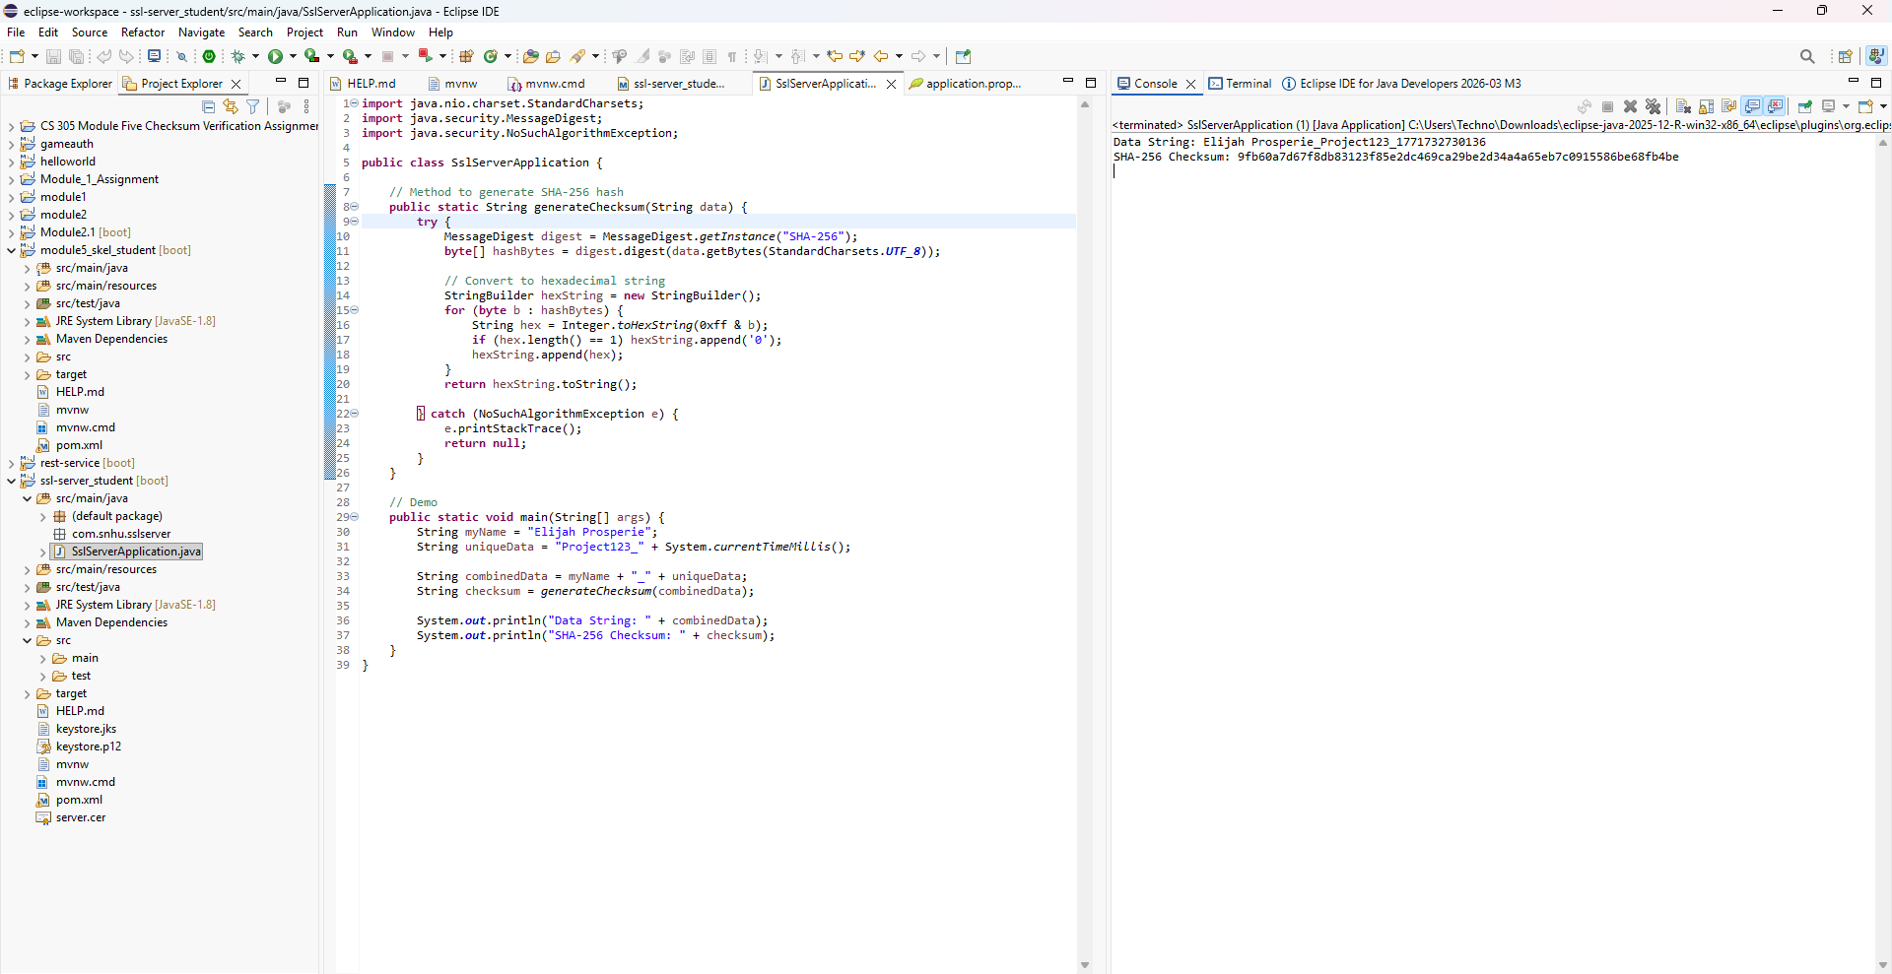

Secure Communications
Insert a screenshot below of the web browser that shows a secure webpage.

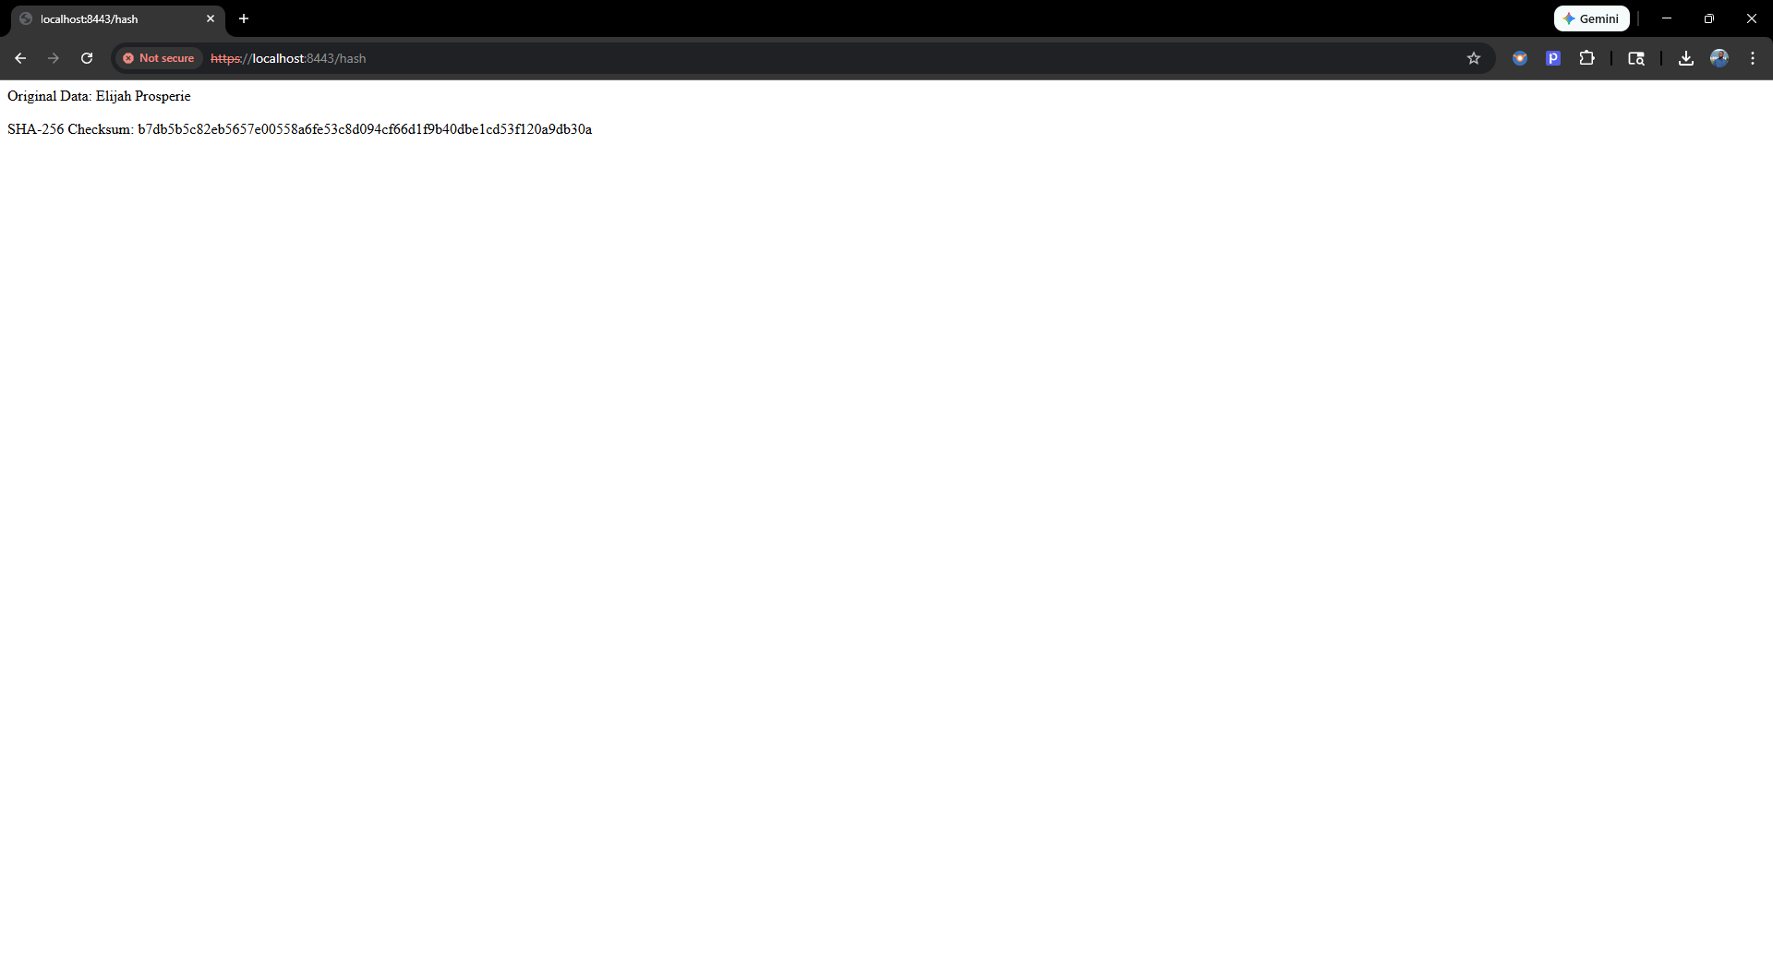

Secondary Testing
Insert screenshots below of the refactored code executed without errors and the dependency-check report.

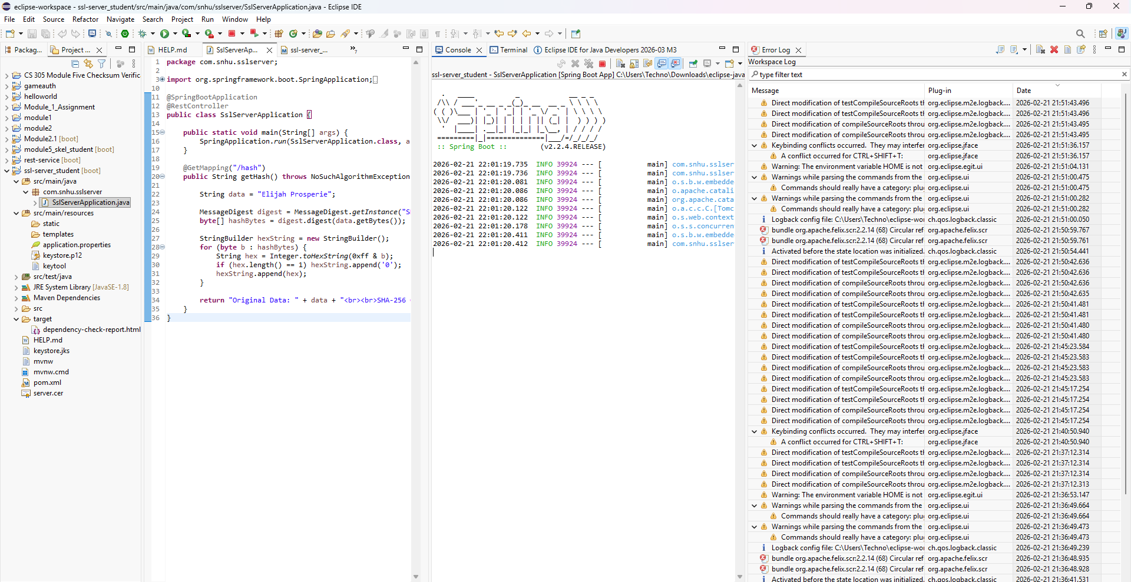
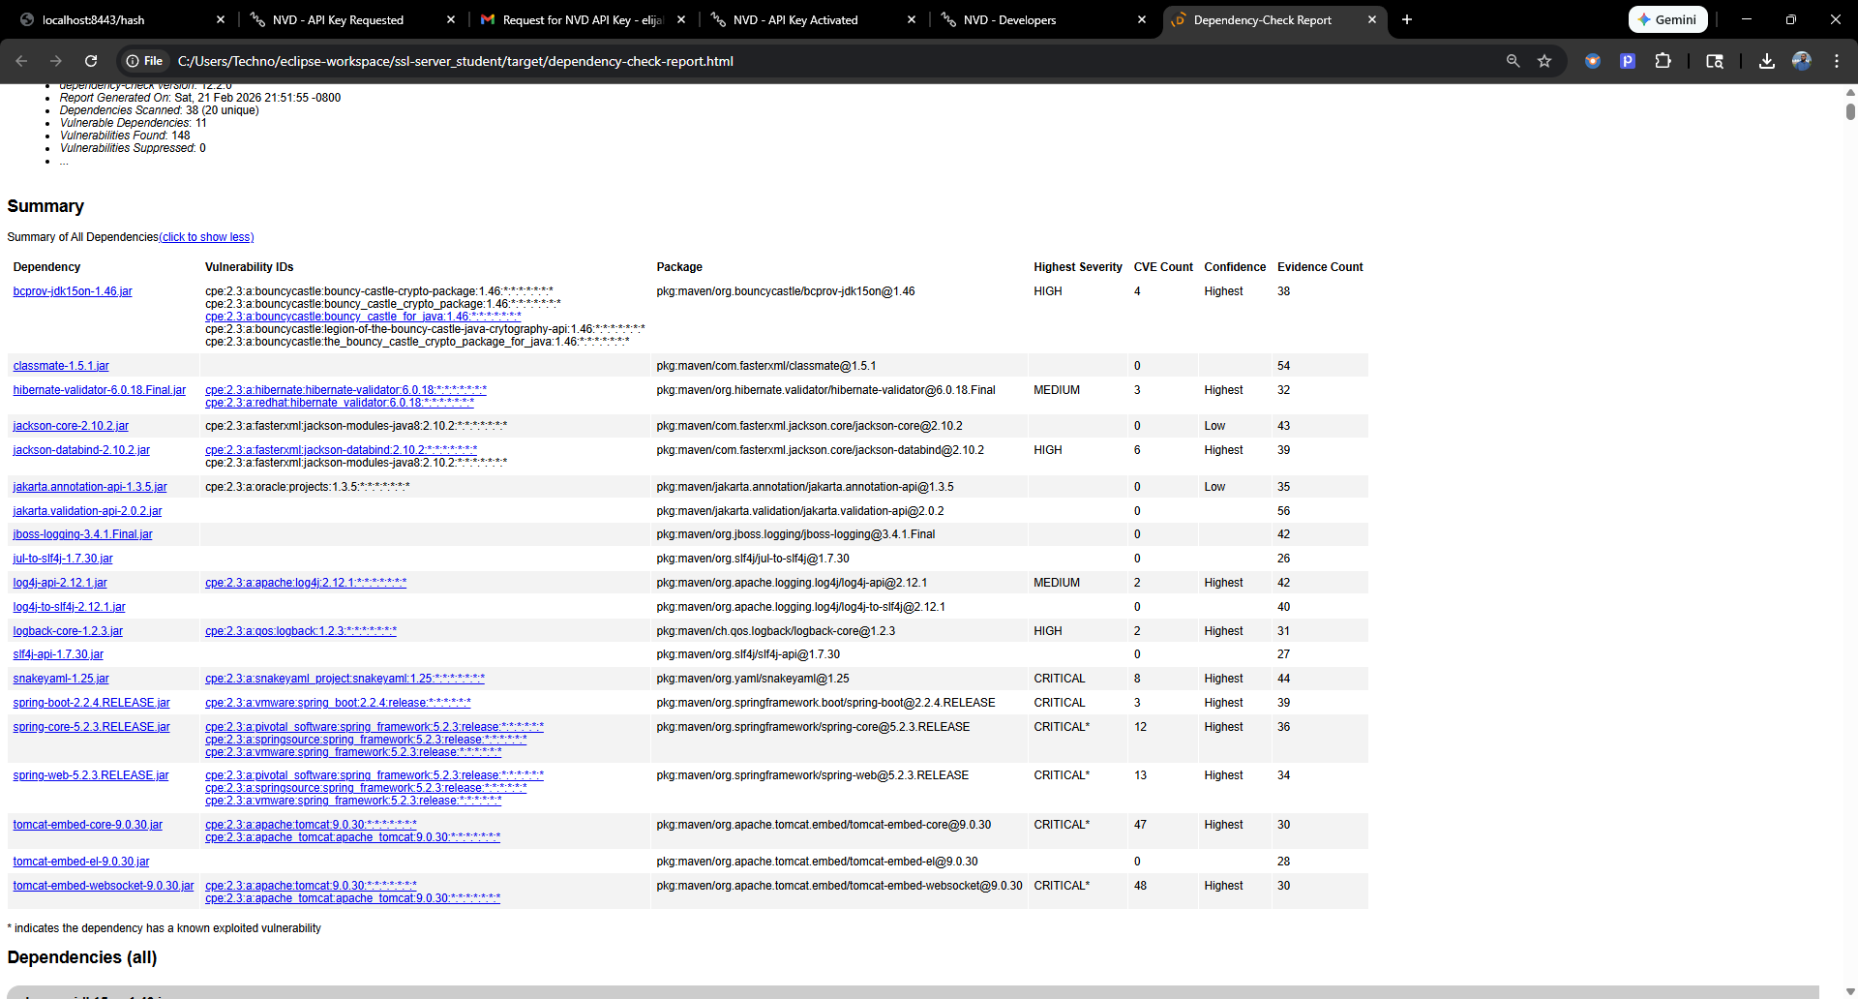

Functional Testing
Insert a screenshot below of the refactored code executed without errors.

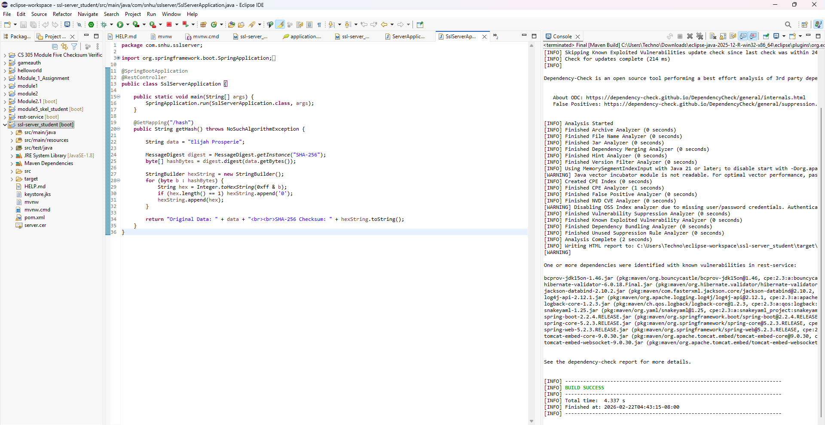

Summary

To complete this portion of the assignment. I had looked through my code multiple times and made sure it was refactored appropriately to identify vulnerabilities, assess risk, remediate weaknesses, and test it’s security. The areas I focused on addressing were as follows:
- Authentication
  - This security focuses on ensuring the identity of users, be it customer or advisor, is secure and confirmed before any access is granted. Helping prevent sensitive information from being viewed by those without proper authentication.
- Authorization
  - Similar to authentication, authorization is necessary for ensuring access is only given to an individual based on their status. A customer cannot access advisor positions, but an Advisor would have authorization to access customers within reason. While authentication keeps those without access to the accounts out. Authorization ensures that restrictions are based on the role itself.
- Data Protection
  - This security measure is one of the most relevant regarding this specific app. Artemis Financial handles PII(Personally identifiable information) such as records, SSI, and other sensitive information that is high-level risk. Encrypting that data is a must in preventing identity fraud and data theft.
- Input Validation
  - Ensuring that the correct inputs are validated helps prevent attackers from using exploits on browser submission forms to give them access to customer, or advisory, data.
- Session Management
  - This one is more niche, but a lot of applications today have some form of remember me or login-check. Making sure security is checking the cookies and making session expirations is a good way of protecting from attackers bypassing an active session.
- Logging and Monitoring
  - Building off session management. It’s also important to log and keep updated on multiple login attempts. Especially if those are from different IP addresses or devices. Sending the owner’s confirmation emails/text is a good way to keep customers in the loop of their accounts' security.
- Error Handling
  - Finally, proper error handling can help reduce hackers' access to databases through generating generic, simple messages that do not reveal information that can help deduce security within the databases.

Industry Standard Best Practices

Throughout this assignment, I’ve refactored and edited my work as I went along to ensure that I was following Industry standards. I went back and added comments to my code to allow another viewer to easily follow what was being done. I used the OWASP dependency-check tool to search for CVE’s, or Common Vulnerabilities and Exposures. Ensuring that any libraries added had no major insecurities or weaknesses. Using techniques such as HTTPS and Principle of Least Exposure helps keep the code secure and maintain proper protocols.

These standards are necessary in creating an application that is functional and secure. As well as ensuring that any that also need to look at your work will be able to follow wherever you left off with little to no issue. Following industry standards also means that sensitive information is protected properly from breaches and unauthorized access. As well as create customer trust in the process.

